**Team leader:**

Ben Zhang:          A00976551

**Team members:**

Andrew Main:     A00815430

Phat Le:               A01012144

Simon Shoban:    A00985653

Cameron Roberts:  A00966003

**Milestone 3 – Skeleton website**

**Game Review 8™ Game Review Web System**

**COMP 1536 Group 6**

**Date: 02-15-2017**

**Table of Contents**

**1. Overview**

1.1 Link

1.2 List of items completed

        1.3 Additional work

**2. Documentation of work**

2.1 Screenshots of front page

        2.2 Screenshots of table

2.3 Screenshots of form

**3. Key issues**

3.1 Encountered problems

3.2 Outstanding problems

**4. Testing**

4.1 A/B testing

4.2 Accessibility testing

4.2.1 Browser compatibility

4.2.2 Device compatibility

4.3 HTML/CSS validation

**Appendix**

**1.Overview**

This document showcases the skeleton websites of our game review system. It provides the quick links, documentation of work, list of key issues we encountered, and documentation for A/B testing.

**1.1 Link**

Index page:

Devices page – Console :

Devices page – Handheld:

Devices page – Mobile:

Devices page – PlayStation 4:

Devices page – Xbox One:

Devices page – Nintendo Switch:

Consoles page – PC:

Consoles page – PlayStation Vita:

Consoles page – Nintendo 3DS:

Consoles page – iOS:

Consoles page – Android:

About page:

Sign up page:

**1.2 List of items completed**

* Standard HTML template for all pages
* Base CSS template for all pages
* Skeleton pages for the entire website
* Skeleton page for Sign up and Review pages that contains a form
* Skeleton pages for Consoles that contain tables
* Implemented responsive design for all pages
* Tested pages on Internet Explorer, Mozilla Firefox, Microsoft Edge, and Google Chrome.
* A/B Testing

**2.Documentation of work**

**2.1 Screenshots of front page**

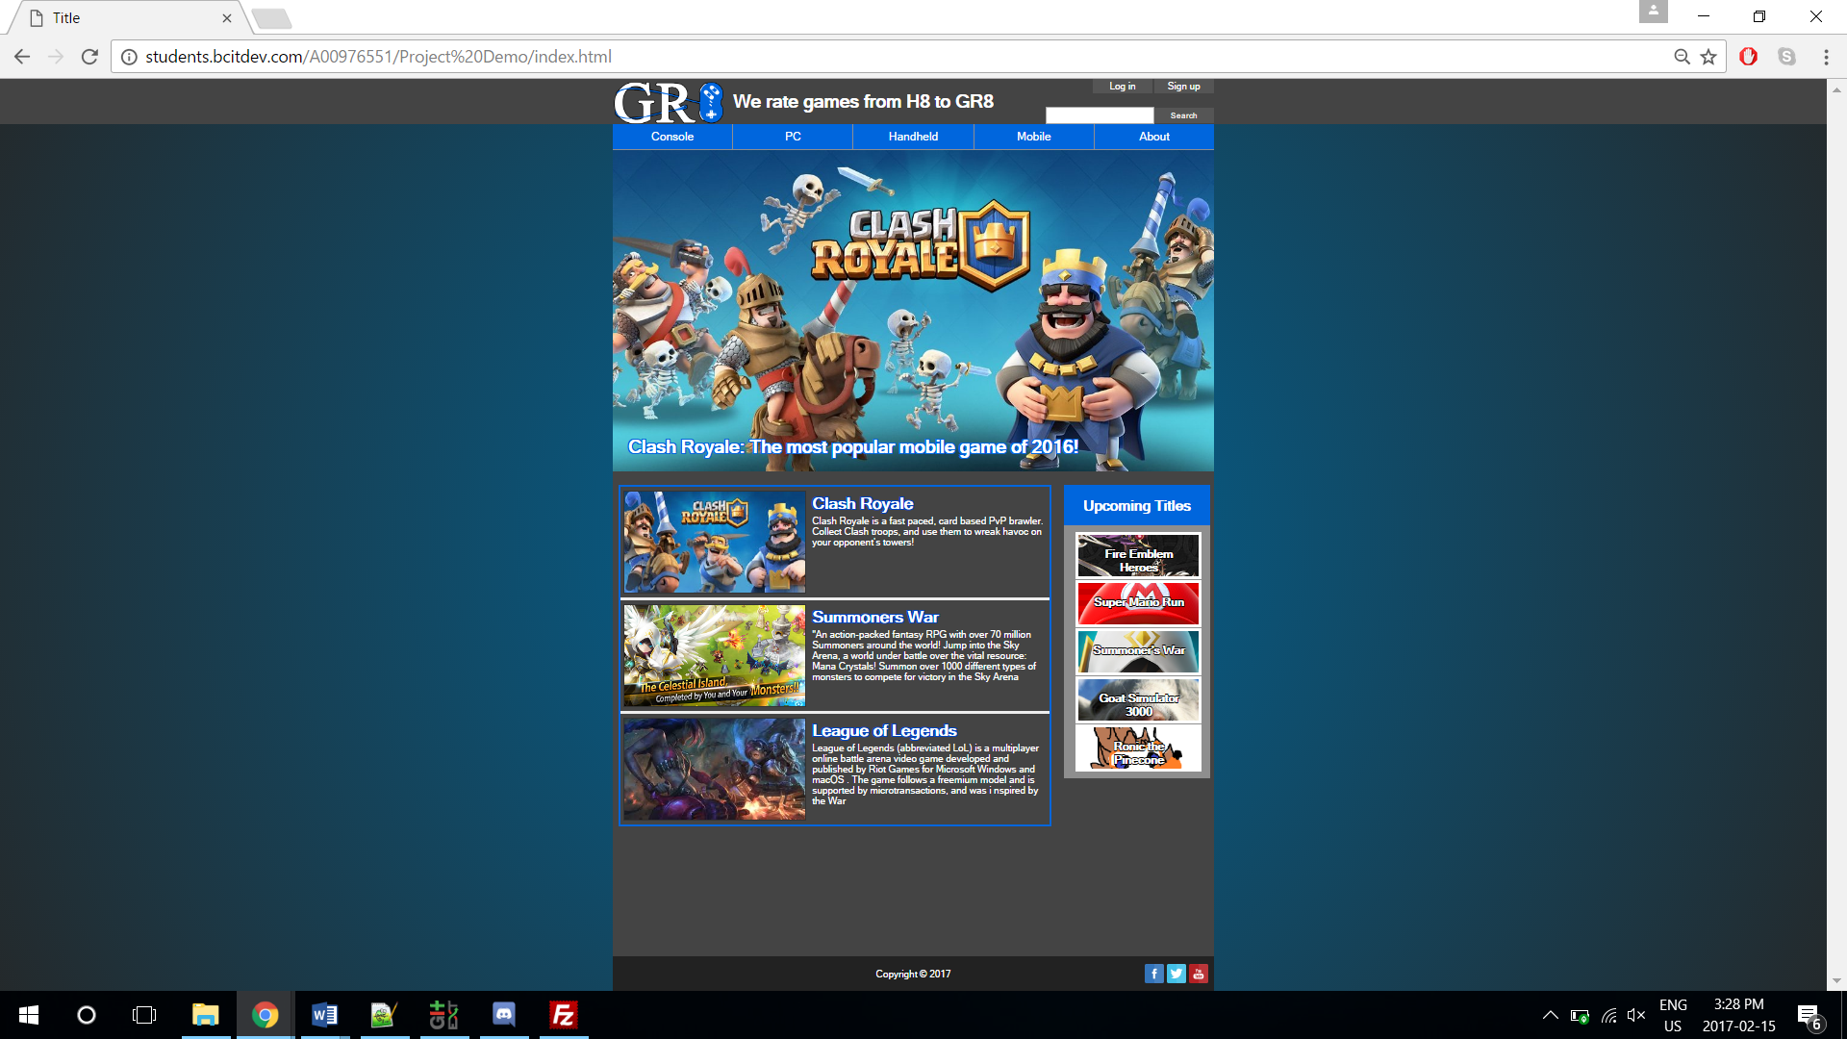

**2.2 Screenshots of table**

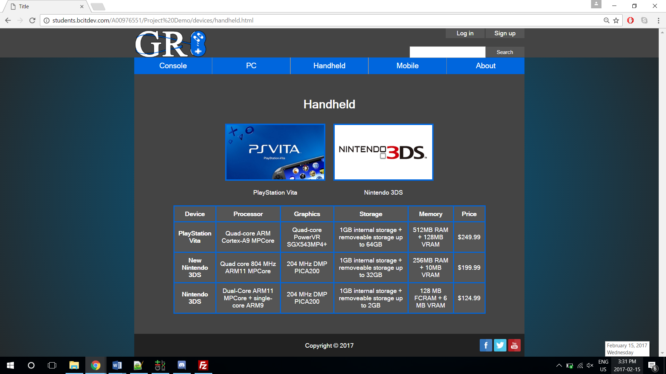

**2.3 Screenshots of form**

**3.Key issues**

**3.1 Encountered problems**

During the development of our webpages, we found that the initial design scales poorly on different screen resolutions. Therefore, we adjusted the website structure from being static to window rescaling to responsive. Also, we used media query and viewport to adjust the elements of the website to fit on a mobile device.

**3.2 Outstanding problems**

**4.Testing**

**4.1 A/B testing**

**4.2 Accessibility testing**

**4.2.1 Browser compatibility**

**4.2.2 Device compatibility**

**4.3 HTML/CSS validation**